Table of Contents

**INTRODUCTION** 3

1. History of the hardware 4

2. Hardware classification 5

2.1 Personal computer 5

2.1.1 Case cover 5

2.1.2 The source 6

2.1.3 Motherboard 6

2.2 Big computer 6

3. Computer hardware 7

3.1. What is the hardware 7

3.2 Hardware classification of the computer 8

4. Basic components of the hardware 8

4.1 CPU-Central Processing Unit 8

4.2 Mainboard 9

4.3 RAM - Random Access Memory 9

4.4 Hard Disk Drive 10

4.5 Input devices 11

4.6 Screen 11

4.7 Network card 12

4.8 Keyboard 13

4.9 Mouse 13

5. Conclusion 14

6. Reference list 14

**HARDWARE**

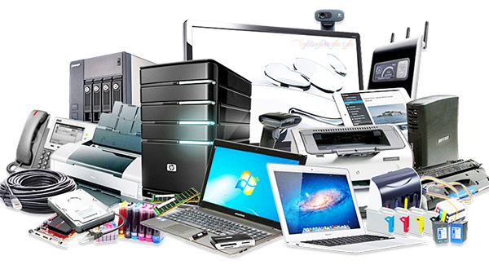

# **INTRODUCTION**

Currently, the information technology industry is one of the industries with the strongest development. The industry's contribution to our present lives is enormous, thanks to the technology that supposedly rigid tasks are done more easily and quickly. It is this that helps reduce our burden at work. As students of information technology, more than anyone else, we understand this issue. Due to practical requirements and awareness of the importance of the problem, I chose the topic "Hardware of the computer" for my report.

The contents of the report include the following:

* Basics about hardware
* Classification of computer hardware
* State the details of computer hardware components

1. History of the hardware

The evolutionary classification of electronic computer hardware is divided into generations, where each generation represents a remarkable technological change. The origins of the first generations were simple to set up, because in it the hardware underwent radical changes. The essential components of the computer electronics were completely replaced in the first three generations, causing transcendent changes. Over the past decades, distinguishing new generations has become more difficult, as changes have been gradual and there is a certain continuity in the technologies used. In principle, you can distinguish:

* Generation 1 (1945-1956): electronics made with vacuum electronic lights. They were the first machines to move electromechanical components (relays).

*2nd generation (1957-1963): electronics developed with transistors. Discrete logic is very similar to the previous logic, but the performance is much smaller, reducing, among other factors, the size of a computer at considerable scale.

*3rd generation (1964-today): electronics based on integrated circuits. This technology allows the integration of hundreds of transistors and other electronic components into a single integrated circuit printed on a silicon wafer. Computers have dramatically reduced costs, consumption and size, and increased capacity, speed, and reliability to produce machines like those that exist today.

*4th generation (future): will probably originate when silicon circuits, integrated on a large scale, are replaced with a new material or technology.

The arrival of microprocessors marked a milestone and for many authors, it formed the beginning of the fourth generation. Unlike previous technological changes, inventing them does not mean the complete disappearance of computers that do not use it. Therefore, although the 4004 microprocessor was launched in 1971, in the early 1980s, there were computers, such as PDP-11/44, [8] used it as a microprocessor. Logic continues to succeed in the market; that is, in this case the shift has been very gradual.

Another common technology milestone used to determine the beginning of the fourth generation was the appearance ò VLSI (very large scale integratiom) integrated circuits,in the early 1980s that does not mean immediate change and the rapid disappearance of computer based on integrated ciruts at a lower intergrated scale.Many devies deployed with VLSI and MSI(medium scale integartion) ramained successful until the 1990s.

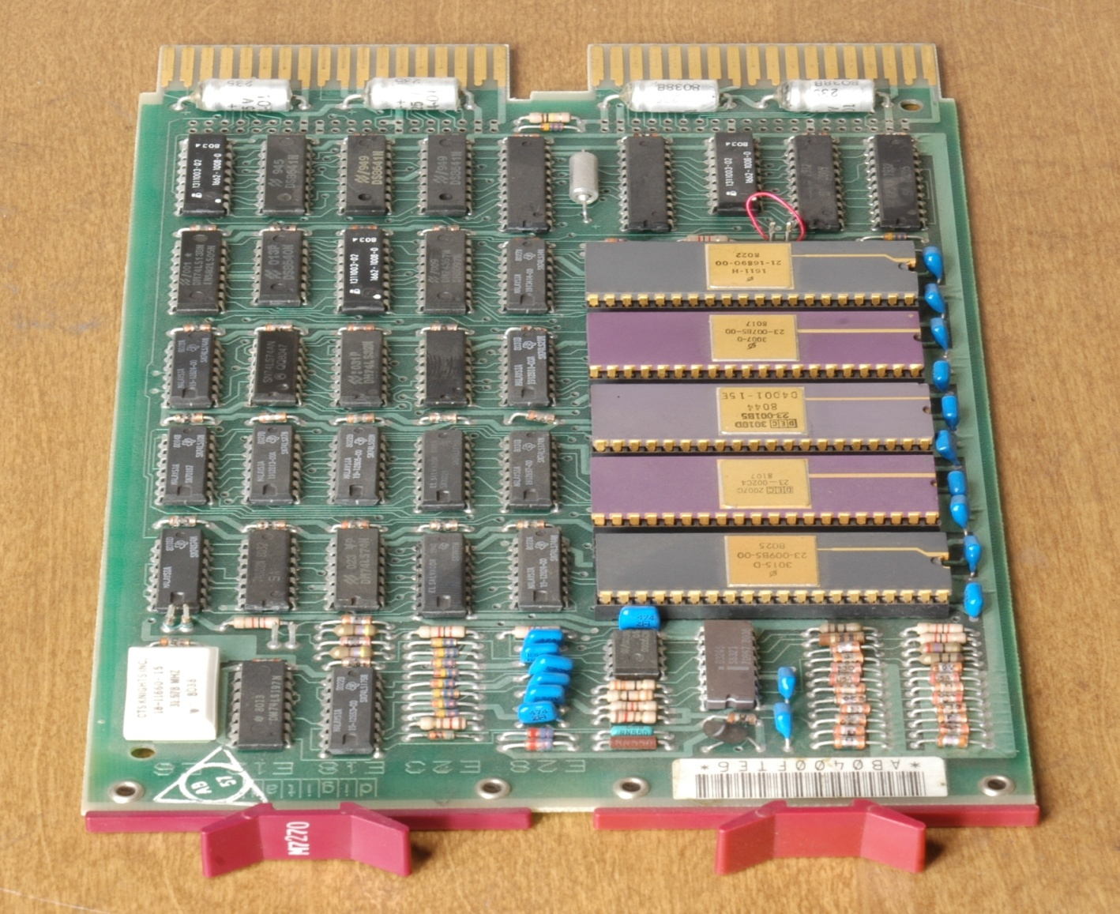

CPU board PDP-11

2. Hardware classification

2.1 Personal computer

Personal computers, also known as PCs, are one of the most popular computers due to their flexibility and relatively low price. Laptops in general are very similar, although they may use lower size components or reduce the size, thus lower performance.

2.1.1 Case cover

The computer case surrounds most components of the system. It provides mechanical support and protection for internal elements such as the motherboard, the drive and the power supply, and controls and directs the cooling airflow through internal components. The case is also part of the system to control electromagnetic interference radiated by the computer and protect internal components from electrostatic discharge. The large tower case provides more internal space for many drives or other peripherals and usually stands on the floor, while the desktop case provides less space. Apple's all-in-one style design, namely the iMac and the like, includes a video monitor built into the same case. Mobile computers and laptops require cases that provide impact protection for the device. A current development in laptops is a detachable keyboard, which allows the system to be configured as a touch screen tablet. Players can decorate cases with colored lights, paint or other features, in an activity called case modification.

2.1.2 The source

The power supply unit (PSU) converts the alternating current (AC) power into a low voltage DC power source for the internal parts of the computer. Laptops can run from built-in batteries, usually for a period of time.

2.1.3 Motherboard

The motherboard or motherboard is the main component of the computer. It is an integrated circuit board that connects other parts of the computer including the CPU, the RAM, the drive (CD, DVD, hard drive ...). ) as well as any peripherals connected via ports or expansion slots.

2.2 Big computer

A mainframe is a much larger computer, often filling a room and can cost hundreds or thousands of times more than a personal computer. They are designed to perform large amounts of calculations for governments and large businesses.

Based on the function and how it works, people also distinguish hardware into:

* Input or input: Parts of data collection or commands such as keyboard,mouse ...
* Output or output: Parts that answer, signal, or execute commands externally, such as monitors, printers, speakers, etc.

3. Computer hardware

3.1. What is the hardware

Hardware is the device inside and outside the computer that we can hold, visible. Computer hardware is the part that makes up a computer. Such parts include:

* External: Computer monitor, headphone, keyboard, mouse, mouse, printer, projector, speakers, USB, ..
* Internal parts: power supply, CPU chip, mainboard motherboard, Modem, cooling fan, RAM, ROM, sound card, video card, some Drive such as Bluray, CD-ROM, DVD, hard drive, drive floppy disk,…

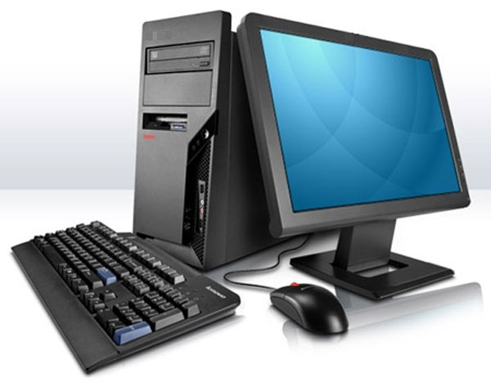

3.2 Hardware classification of the computer

* Input: These are the parts that are responsible for collecting collected data into computers such as mice, keyboards, headsets, etc.
* Output: the parts that execute the command and the external output data, the parts answering, transmitting signals such as monitors, printers, speakers, ...

4. Basic components of the hardware

4.1 CPU-Central Processing Unit

* As a small circuit, the inside contains a silicon wafer wrapped in a ceramic chip and attached to the mainboard.
* CPU speed is measured in Hertz (Hz) or Gigahertz (GHz). The larger this value is, the faster the CPU operates.

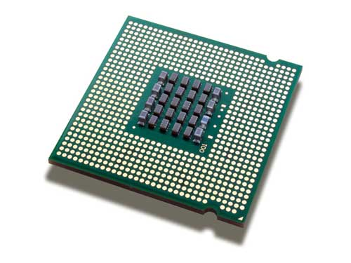

4.2 Mainboard

* As the main board, the most important part in a computer system. It acts as an intermediary to connect and communicate between other devices in the computer.
* As the main board, the most important part in a computer system. It acts as an intermediary to connect and communicate between other devices in the computer.

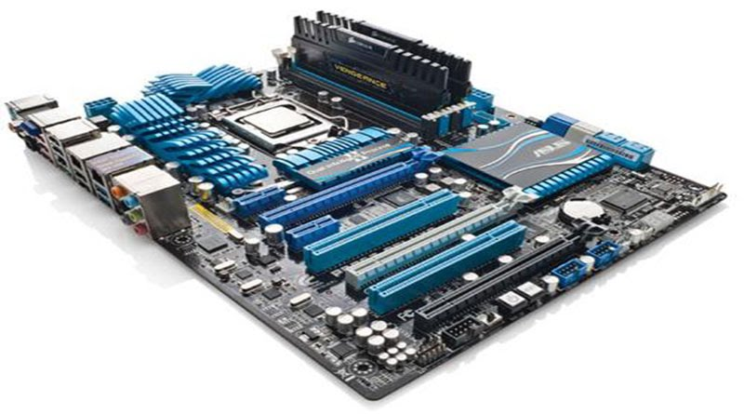

4.3 RAM - Random Access Memory

* A device that allows data storage for a short period of time. PC memory stores information for software installed on the computer to access and retrieve data.
* RAM is the place where a computer access to process information temporarily. This means that when the computer is idle, the RAM will be empty. The bigger the RAM, the more the workload it solves.

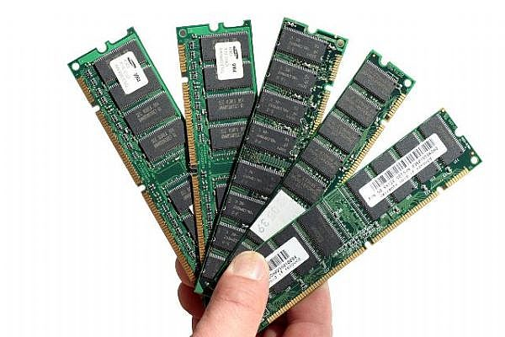

4.4 Hard Disk Drive

* As the main storage unit of a computer, it is a device containing circular plates covering the magnetic layer to store data.
* Hard drive is a place to store the operating system of the machine, all software and all data. When the power is turned off, everything you just worked on your computer will be kept on your hard drive without worrying about being lost or deleted on reboot.
* Hard drive capacity is measured in Gigabytes (GB). Each ordinary hard drive can hold 500 GB or even up to 1000 GB ~ 1TB.

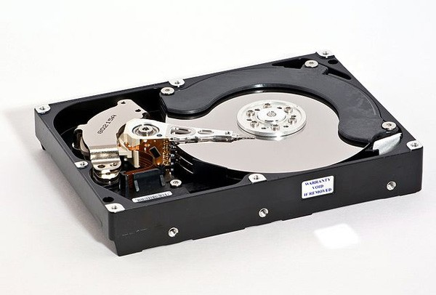

4.5 Input devices

These are devices that help provide data and scripts for computers such as: mouse, touchpad, trackball, keyboard, drawing board, ...

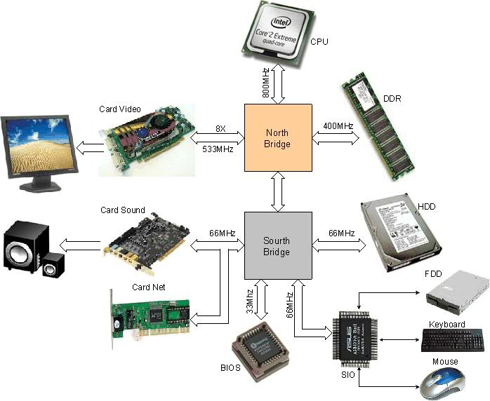

4.6 Screen

* Is an indispensable electronic device. They have the main effect of displaying and connecting the communication between the user and the computer.
* Currently, there are many types of touch screen integrated so you can use your finger to touch the screen to manipulate and control the computer.

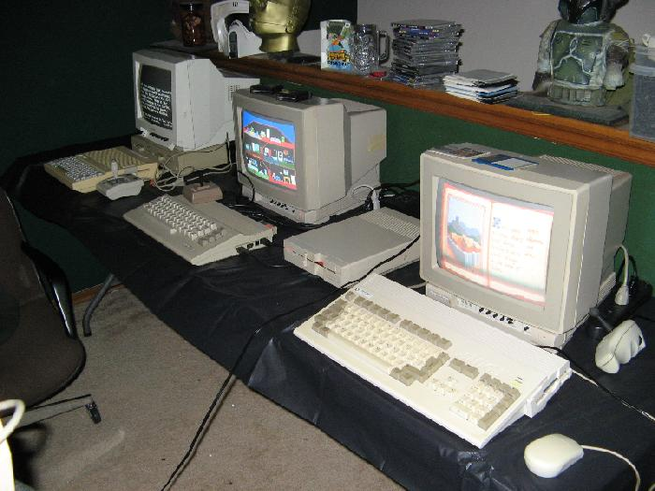

4.7 Network card

* To be able to connect to the Internet, you will definitely need a network card. For the most part, computers today have at least one LAN card (wireless or wired) built into the motherboard
* So you can connect to the Internet routers of the carriers.
* When the network card has a problem, you can attach a removable network card to the expansion slot on the inside of the computer (PCI or PCI Express 1x) or a removable card connected via USB

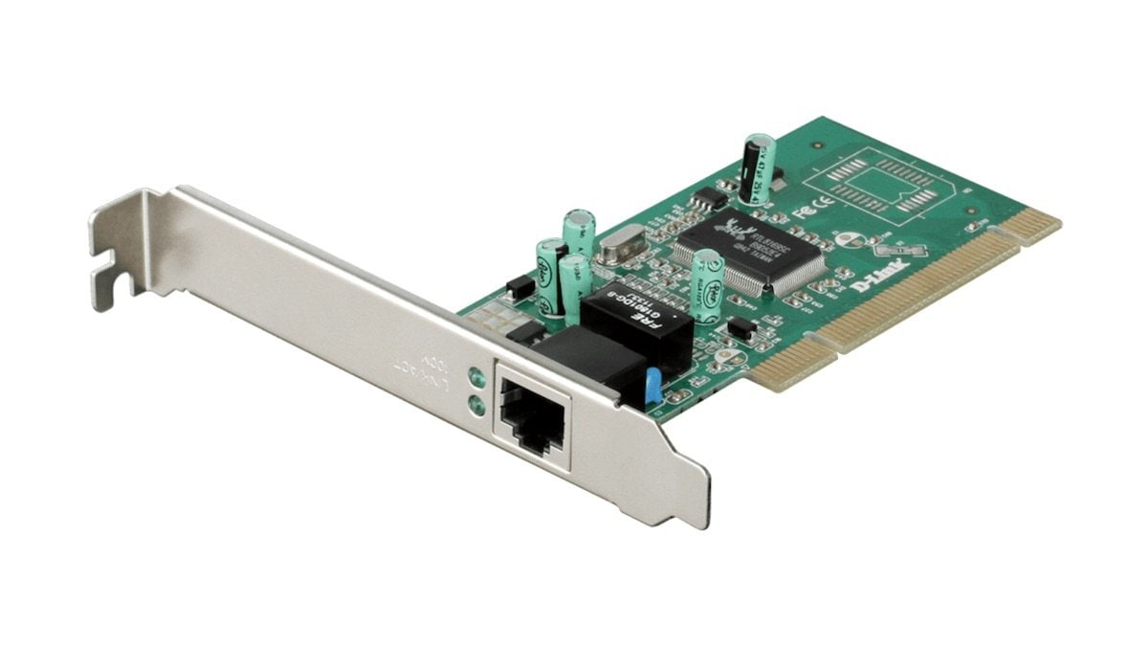

4.8 Keyboard

Computer keyboard is a device for inputting and communicating people with computers. In terms of shape, the keyboard is a arrangement of keys, a regular keyboard with characters printed on the key; For most keyboards, one keypress each time a symbol is generated.

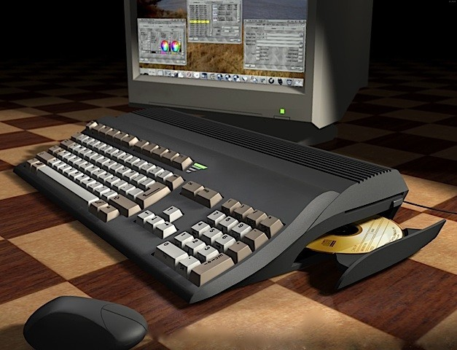

4.9 Mouse

A mouse is a device that controls, commands, and communicates people with computers. To use a computer mouse, it is essential to use a computer screen to observe coordinates and mouse movements on the screen.

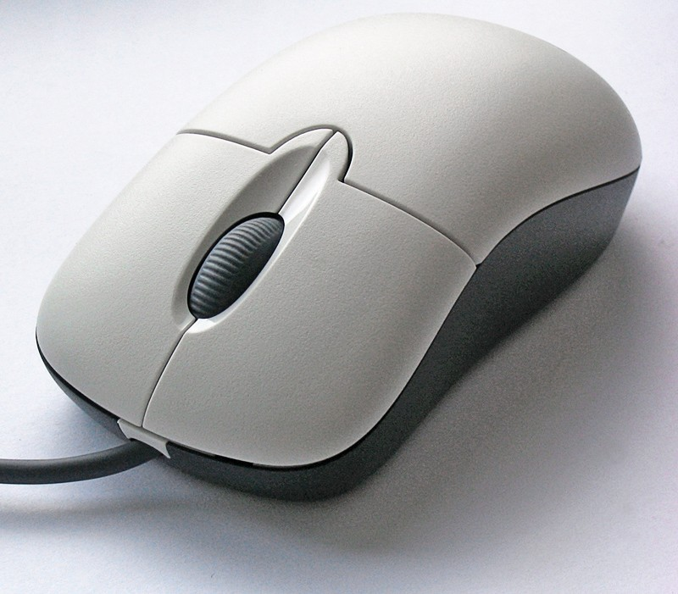

5. Conclusion

Hardware is a physical component that connects to a computer and can be physically touched. Some examples of hardware include video card, printer, computer display monitor, and hard drive. The important of hardware is giving the software a platform to run on. The software cannot operate with hardware since it is the base it can run. The software and hardware interacts with each other with the purpose of fulfilling a given task. Without these two components, a computer system cannot operate effectively.

6. Reference list

[1] [Phần cứng – Wikipedia.org](https://vi.wikipedia.org/wiki/Ph%E1%BA%A7n_c%E1%BB%A9ng)

[2[] https://tailieu.vn/doc/bao-cao-thuc-tap-tim-hieu-phan-cung-may-tinh-1719841.html](https://wru-my.sharepoint.com/personal/1851061983_e_tlu_edu_vn/Documents/%5d%20https:/tailieu.vn/doc/bao-cao-thuc-tap-tim-hieu-phan-cung-may-tinh-1719841.html)

[3] <https://xemtailieu.com/tai-lieu/tim-hieu-phan-cung-may-tinh-luan-van-do-an-de-tai-tot-nghiep-1459882.html>

[4] <https://thegioinotebook.com.vn/phan-cung-may-tinh-la-gi/>